Business Question and Visualization Report

Date
Team ID | MCA
Project Name | Smartphone Usage, Digital Addiction & Well-Being Analytics
Maximum Marks | 5 Marks

Visualization development refers to the process of creating graphical representations of data to facilitate understanding, analysis, and decision-making. The goal is to transform complex datasets into visual formats that are easy to interpret, enabling users to gain insights and make informed decisions. Visualization development involves selecting appropriate visual elements, designing layouts, and using interactive features to enhance the user experience. This process is commonly associated with data visualization tools and platforms, and it plays a crucial role in business intelligence, analytics, and reporting
Business Questions and Visualisation
The project aims to analyze smartphone usage patterns, digital addiction, lifestyle habits, and well-being indicators. Power BI visualizations are used to identify important patterns and relationships between screen time, application usage, sleep, physical activity, stress, productivity, and digital addiction.
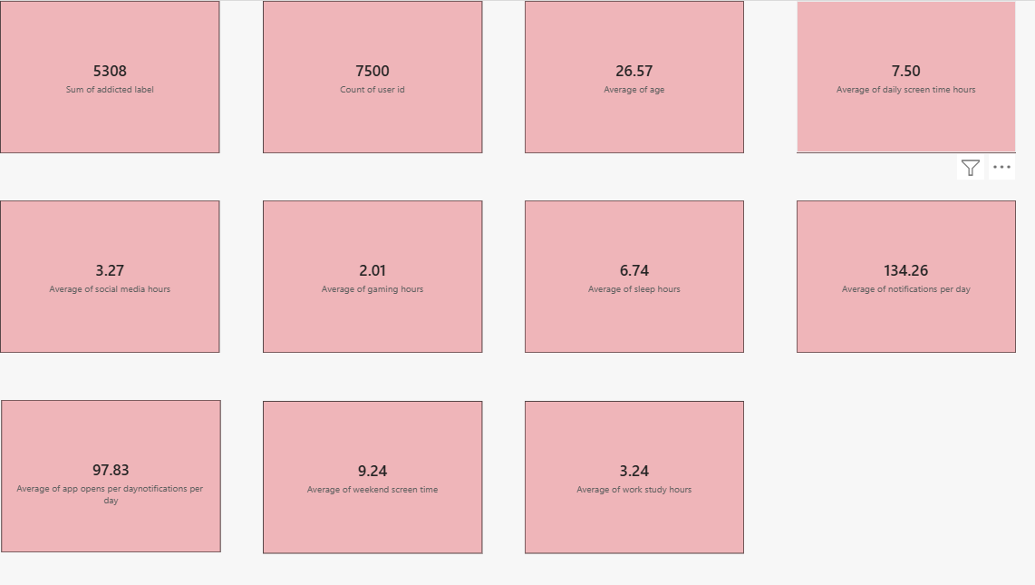

1. What is the overall level of smartphone addiction among the users?
- Visualization: Donut chart showing Addicted vs Non-Addicted users.

- Key Insight: The dashboard shows 5,308 addicted users out of 7,500, representing approximately 70.77% of the dataset.
- Screenshot of visualization: Addicted vs Non-Addicted donut chart.
- The overall level of smartphone addiction among the users refers to the extent to which individuals depend on and excessively use smartphones in their daily lives. Smartphone addiction can be assessed through factors such as frequency of smartphone use, duration of use, inability to control usage, dependence on the device, interference with daily activities, and feelings of anxiety or discomfort when the smartphone is unavailable.
- Based on the responses collected from the users, the overall level of smartphone addiction can be classified into low, moderate, or high depending on the scores obtained through the smartphone addiction scale. A moderate level would indicate that users generally rely on smartphones regularly for communication, entertainment, education, social media, and other activities, but their usage may not always seriously interfere with their daily responsibilities. A high level would indicate excessive and difficult-to-control smartphone use, with possible effects on sleep, concentration, academic/work performance, social relationships, and daily activities.
- Therefore, the study helps to identify the extent of smartphone dependency among the selected users and highlights the importance of maintaining balanced and responsible smartphone usage. The findings can also be useful in creating awareness about healthy digital habits and reducing problematic smartphone use.
- For your project, the final conclusion should be based on your actual survey results (mean score/percentage). If you send me your project questionnaire or survey data, I can write the exact result for this question, including percentage, mean score, interpretation, and a project-ready conclusion.

2.How many users fall under each addiction level?
- Visualization: Bar chart showing the count of users by Addiction Level.
- Key Insight: The dashboard categorizes users into None, Mild, Moderate, and Severe addiction levels. Moderate and Severe categories contain substantial numbers of users.
- Screenshot of visualization: Count of User ID by Addiction Level bar chart.
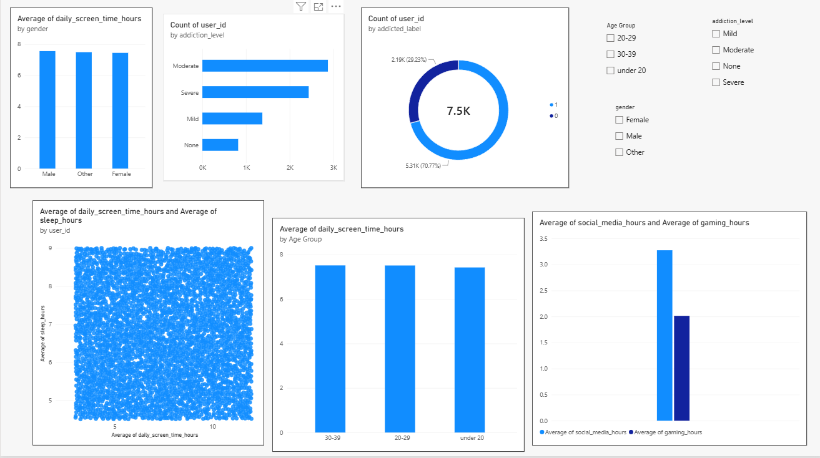

3. How does average daily screen time vary by gender?
- Visualization: Column chart showing Average Daily Screen Time by Gender.
- Key Insight: The visualization compares average daily screen time among Male, Female, and Other users. The values are relatively close across the three groups.
- Screenshot of visualization: Average Daily Screen Time by Gender column chart.
4. How does average daily screen time vary across different age groups?
- Visualization: Column chart showing Average Daily Screen Time by Age Group.
- Key Insight: The visualization compares screen-time behaviour among Under 20, 20–29, and 30–39 age groups.
- Screenshot of visualization: Average Daily Screen Time by Age Group column chart.
5. What is the relationship between daily screen time and sleep hours?
- Visualization: Scatter plot showing Daily Screen Time Hours and Sleep Hours.
- Key Insight: The scatter plot allows the relationship between smartphone screen time and sleep duration to be examined across individual users.
- Screenshot of visualization: Daily Screen Time Hours vs Sleep Hours scatter plot.
6. How do gaming and social-media usage compare among users?
- Visualization: Column chart comparing Average Gaming Hours and Average Social Media Hours.
- Key Insight: The dashboard shows an average of 2.01 hours of gaming and 3.27 hours of social-media usage, allowing comparison of the two major digital activities.
- Screenshot of visualization: Average Gaming Hours and Average Social Media Hours chart.
7. What are the key overall smartphone usage and well-being indicators?
- Visualization: KPI/Card visualizations.
- Key Insight: The dashboard reports 7.50 hours average daily screen time, 9.24 hours average weekend screen time, 6.74 hours average sleep, 97.83 app opens per day, 134.26 notifications per day, and 3.24 hours average work/study time.
- Screenshot of visualization: KPI cards dashboard.
8. What is the average age and overall user population represented in the dataset?
- Visualization: KPI/Card visualizations showing Total Users and Average Age.
- Key Insight: The dataset contains 7,500 users, with an average age of 26.57 years. The dashboard also shows 20–29 as an important age group within the analysed population.
- Screenshot of visualization: Total Users and Average Age KPI cards.
9. How do smartphone usage activities compare between gaming and social media?
- Visualization: Clustered column chart comparing Gaming Hours and Social Media Hours.
- Key Insight: Social-media usage averages 3.27 hours, while gaming averages 2.01 hours, providing a comparison of two major categories of digital activity.
- Screenshot of visualization: Gaming and Social Media comparison chart.
10. What is the average level of user engagement with smartphones?
- Visualization: KPI/Card visualizations for App Opens per Day and Notifications per Day.
- Key Insight: Users open applications an average of 97.83 times per day and receive approximately 134.26 notifications per day, providing indicators of smartphone engagement.
- Screenshot of visualization: App Opens and Notifications KPI cards.

